**DAILY ONLINE ACTIVITIES SUMMARY**

|  |  |  |  |  |  |  |  |
| --- | --- | --- | --- | --- | --- | --- | --- |
| **Date:** | **02/06/2020** | | | | **Name:** | **Namratha C** | |
| **Sem & Sec** | **8th sem, A sec** | | | | **USN:** | **4AL16CS056** | |
| **Online Test Summary** | | | | | | | |
| **Subject** | | **No Test Conducted** | | | | | |
| **Max. Marks** | |  | | **Score** | |  | |
| **Certification Course Summary** | | | | | | | |
| **Course** | **Step into Robotic Process Automation** | | | | | | |
| **Certificate Provider** | | | **GUVI** | **Duration** | | | **3 hrs** |
| **Coding Challenges** | | | | | | | |
| **Problem Statement: 1) Java program to find the transpose of a matrix.** | | | | | | | |
| **Status: Completed** | | | | | | | |
| **Uploaded the report in Github** | | | | **Yes** | | | |
| **If yes Repository name** | | | | **CODES (Namrathasonu)** | | | |
| **Uploaded the report in slack** | | | | **Yes** | | | |

Online Test Details: **No test conducted**

Certification Course Details:

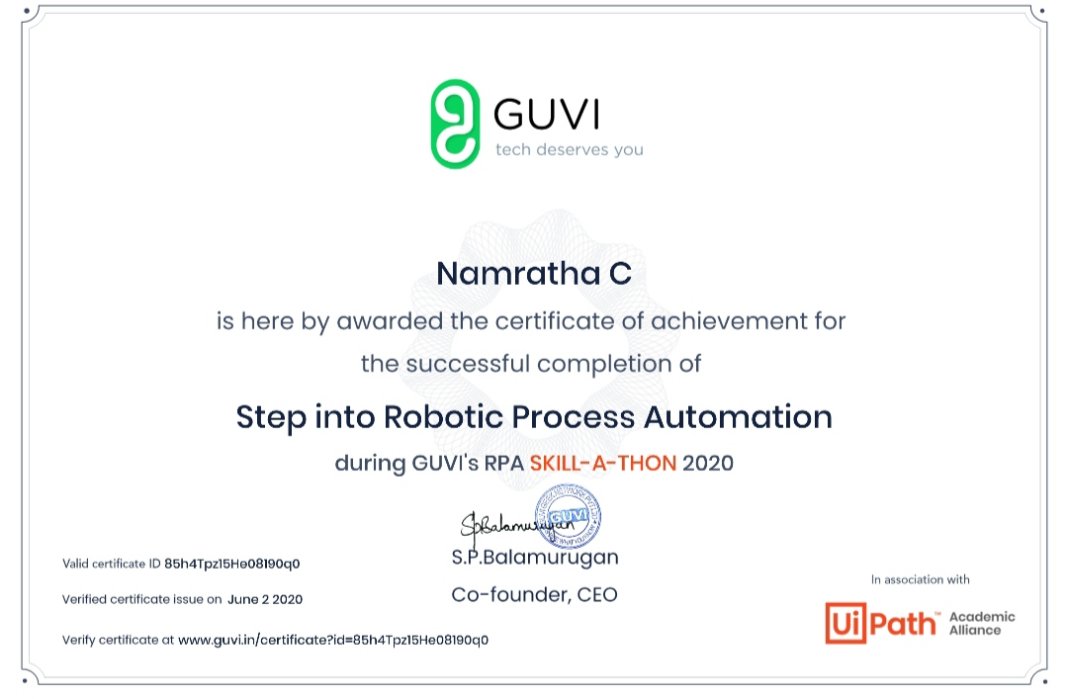

Coding Challenges Details:

1)

public class Transpose

{

public static void main(String[] args) {

int rows, cols;

//Initialize matrix a

int a[][] = {

{1, 2, 3},

{4, 5, 6},

{7, 8, 9}

};

//Calculates number of rows and columns present in given matrix

rows = a.length;

cols = a[0].length;

//Declare array t with reverse dimensions

int t[][] = new int[cols][rows];

//Calculates transpose of given matrix

for(int i = 0; i < cols; i++){

for(int j = 0; j < rows; j++){

//Converts the row of original matrix into column of transposed matrix

t[i][j] = a[j][i];

}

}

System.out.println("Transpose of given matrix: ");

for(int i = 0; i < cols; i++){

for(int j = 0; j < rows; j++){

System.out.print(t[i][j] + " ");

}

System.out.println();

}

}

}